 | 26.9.7 Editors - Geometry Nodes Editor - Header - Add Menu - Hair - Generation modifier
Table of content
Detailed table of content 1
Hair - Generation modifier 3
General functionality 3
Duplicate Hair Curves 4
Generate Hair Curves 5
Interpolate Hair Curves 6

Detailed table of content

Table of content
Detailed table of content 1
Hair - Generation modifier 3
General functionality 3
Output Attributes 3
Internal Dependencies 3
Bake 3
Named Attributes 4
Duplicate Hair Curves 4
Amount 4
Viewport Amount 4
Radius 4
Distribution Shape 4
Tip Roundness 4
Even Thickness 4
Seed 4
Output Attributes 4
Guide Index 4
Internal Dependencies 4
Named Attribute 4
Generate Hair Curves 5
Surface 5
Surface Object 5
Surface UV map 5
Surface Rest Position 5
Hair Length 5
Hair Material 5
Control Points 5
Poisson Disk Distribution 5
Density 5
Density Mask 5
Mask Texture 5
Viewport Amount 5
Seed 6
Output Attributes 6
Surface Normal 6
Internal Dependencies 6
Named Attribute 6
Interpolate Hair Curves 6
Surface Object 6
Surface UV map 6
Surface Rest Position 6
Follow Surface Normal 6
Part by Mesh Islands 6
Interpolation Guides 6
Distance to Guides 6
Poisson Disk Distribution 6
Density 7
Density Mask 7
Mask Texture 7
Viewport Amount 7
Seed 7
Output Attributes 7
Guide Index 7
Surface Normal 7
Internal Dependencies 7
Named Attribute 7

Hair - Generation modifier
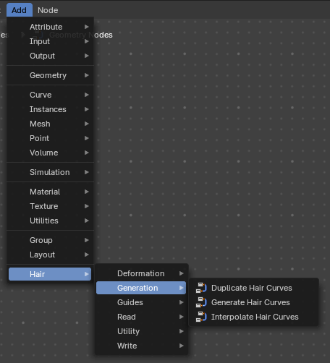
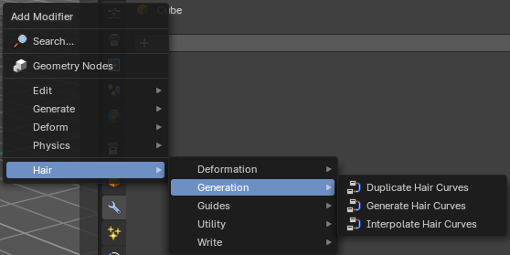

Hair nodes are Geometry node groups found in the Essentials Library included with Bforartists. They differ from the other nodes in the add menu due to being mid level node groups instead of individual low level nodes.
These hair nodes are also available as Modifiers. And this modifier adds the same node group as you would do it in the geometry node editor. Which means you can control these node groups in the modifier stack now instead of the geometry node editor.
Note that hair curves is usually a mesh only functionality. But shows for all other object types too.


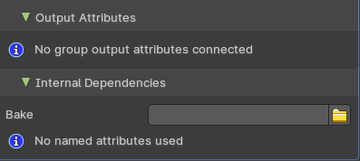
General functionality
All Hair nodes have an Output Attributes and Internal dependencies tab. If the hair node has output attributes or internal dependencies depends of the hair node.

Output Attributes
Contains group output attributes in case the node group has any. It is usually the output of the nodes besides the geometry.

Internal Dependencies

Bake
Define a bake name and a bake folder.
TODO: find out how this is meant to work.

Named Attributes
Named attributes of the hair node group in case the group has any.

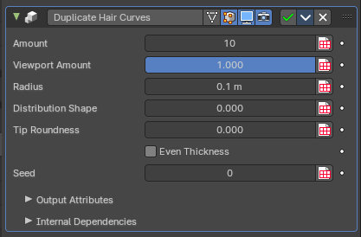
Duplicate Hair Curves
Duplicates hair curves a certain amouunt of times in the given radius.

Amount
Amount of duplication per curve.

Viewport Amount
How much percent is used in the viewport.

Radius
The radius in which the duplicate curves are offset from the guides.

Distribution Shape
Shape of distriubution from center to the edge aroudn the guide.

Tip Roundness
Offset of the curves to round the tip.

Even Thickness
Keep an even thickness of the distribution of duplicates.

Seed
Random seed for the operation.


Output Attributes

Guide Index
The guide index map that was used for the operation.


Internal Dependencies

Named Attribute
Write attribute with name guide_curve_index

Generate Hair Curves
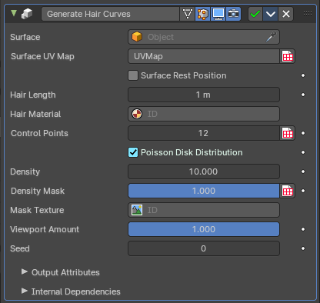
Generates new hair curves on a surface mesh.

Surface
The surface to generate the hairs on.

Surface Object
A surface object to generate the hairs on.

Surface UV map
Surface UV map used for attachment.

Surface Rest Position
Set the surface mesh into its rest position before attachment.

Hair Length
Length of the generated hair curves.

Hair Material
The material for the hair curves.

Control Points
Amount of control points for the generated hair curves.

Poisson Disk Distribution
Use Poisson Disk distribution to keep a minimum distance between the hair curves.

Density
How dense the generated hair curves are.

Density Mask
Factor for the density of generated hair curves.

Mask Texture
Discard points based on a mask texture after distribution. This mask can be loaded here.

Viewport Amount
How dense the generated hair curves are displayed in the viewport.

Seed
Random seed for operation.

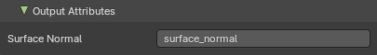
Output Attributes

Surface Normal
The surface normals.


Internal Dependencies

Named Attribute
Write attribute with name surface_uv_coordinate

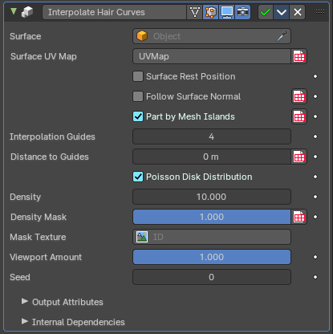
Interpolate Hair Curves
Interpolates existing guide curves on a surface.

Surface Object
A surface object to generate the hairs on.

Surface UV map
Surface UV map used for attachment.

Surface Rest Position
Set the surface mesh into its rest position before attachment.

Follow Surface Normal
Align the interpolated curves to the surface normal.

Part by Mesh Islands
Use mesh islands of the surface geometry for painting.

Interpolation Guides
Amount of guides to be used for interploation per curve.

Distance to Guides
Distance aorund each guide to spawn interpollated curves.

Poisson Disk Distribution
Use Poisson Disk distribution to keep a minimum distance between the hair curves.

Density
How dense the generated hair curves are.

Density Mask
Factor for the density of generated hair curves.

Mask Texture
Discard points based on a mask texture after distribution. This mask can be loaded here.

Viewport Amount
How dense the generated hair curves are displayed in the viewport.

Seed
Random seed for operation.

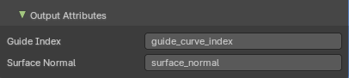
Output Attributes

Guide Index
The output curves.

Surface Normal
The surface normals.


Internal Dependencies

Named Attribute
Read and Write attribute with name surface_uv_coordinate

